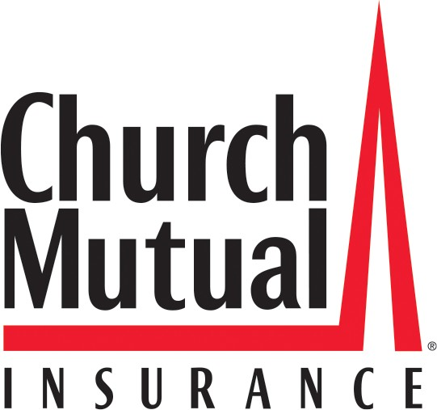
3000 Schuster Lane
P.O. Box 357 Merrill, WI 54452-0357
(800) 554-2642 Fax (855) 264-2329

COVID-19

INFECTION CONTROL PROTOCOL SURVEY

This survey is for use with the following:
Camps, Conference Centers, and Retreat Centers,
Nonprofit and Human Service Organizations, Schools, Colleges, and Universities.

Date: Account Number:
Named Insured:

Clients | Response
The term "clients" may include any of the following: Clients, Residents, Campers, Students, Customers, Patrons, or Members.
1. Are you aware of and following the latest CDC guidance for prevention of transmission? | Yes | No
2. Have you implemented social-distancing policies at each of your premises and have all staff been trained on the new rules? | Yes | No
3. If a client shows signs of a respiratory infection, does your organization report this to the state and local health department immediately and seek their guidance on how to respond? | Yes | No
4. Does your organization isolate suspected COVID-19 clients? If yes, please explain. | Yes | No
5. Does your organization test suspected COVID-19 clients? If yes, what is the turnaround time? | Yes | No
6. Do you permit clients with a confirmed diagnosis of  COVID-19 to continue to stay on premises, continue to live on premises (if you offer housing), or continue to participate in your programs and services? | Yes | No

7. If you answered "yes" to the question 6 above, do you isolate clients with confirmed COVID-19 into a separate section of the premises and prevent clients from other areas of the premises from accessing the area? | Yes | No
8. Will you admit a new client onto your premises with a known or suspected COVID-19 diagnosis? | Yes | No
9. Do you require your clients to sign a waiver that releases you from liability associated with COVID-19? | Yes | No
- For organizations operating overnight or residential facility only:  - Are residents permitted to leave the premises and then Yes return? If yes, what procedures are followed upon their  return?  - For residents on site with suspected or confirmed Yes COVID-19, do you require that they remain in their  rooms with their room doors closed? |  | No  No
Staff | Response
1. Do you have a designated infection control prevention specialist employee/volunteer at each of your Locations? | Yes | No
- Are all employees/volunteers screened in advance with the following questions:  - Have they traveled in the last 14 days?  - Have they had any of the following symptoms in the last 14 days: fever or chills, cough, shortness of breath or difficulty breathing, fatigue, muscle or body aches, headache, new loss of taste or smell, sore throat, congestion or runny nose, nausea or vomiting, or diarrhea?  - Have they had any known contact in the last 14 days with someone infected by or suspected to be infected by COVID-19? (Or presenting the above symptoms?) | Yes  Yes Yes  Yes | No
 |  | No
 |  | No
 |  | No

3. If they answer yes, to any of the questions above in question 2, are they instructed not to come to work? | Yes | No
4. Are the responses to the question number 2 above, from employees/volunteers, documented in writing, and retained in case needed as future proof? | Yes | No
5. Have all employees/volunteers been trained on the above screening process, plus hand hygiene, and cleaning and disinfection protocols for environmental surfaces? | Yes | No
6. Does the organization test suspected COVID-19 employees/volunteers? If yes, what is the turnaround time? | Yes | No
7. Are all employees/volunteers required to wear masks What type of mask is required? | Yes | No
8. For employees/volunteers required to wear masks, are all of them trained on proper fitting/usage? | Yes | No
9. If an employee/volunteer develops symptoms of a respiratory infection while working, are they instructed to stop working, put on a face mask, and self-isolate at home? | Yes | No
10. Does the organization have a contingency plan in place in the event of staffing shortages related to staff being sent home? | Yes | No
Visitors | Response
Visitors means anyone who comes to your premises that is not an employee, volunteer, or client (see broad definition above).
Visitors may include vendors, parents/guardians of clients on your premises, visitors of clients on your premises, etc.
1. Are visitors permitted to enter your premises? If no, skip this section. | Yes | No

- Are all visitors to your organization screened in advance of entry with the following questions:

  - Have they traveled in the last 14 days? Yes No

  - Have they had any of the following symptoms in the Yes No
last 14 days: fever or chills, cough, shortness of breath or difficulty breathing, fatigue, muscle or body aches, headache, new loss of taste or smell, sore throat, congestion or runny nose, nausea or vomiting, or diarrhea?

  - Have they had any known contact in the last 14 days Yes No with someone infected by or suspected to be infected by
COVID-19 (or presenting the above symptoms)?

  - If you elect to admit a visitor that has a concerning Yes No answer to any of the above questions, does admission
require sign-off by management?
- For organizations operating overnight or residential facility only:  - If you are doing such visitor screenings, are the Yes  responses documented in writing and retained in case needed as future proof? |  | No
4. Are visitors required to wear a mask? | Yes | No
5. Do you require your visitors to sign a waiver that releases you from liability associated with COVID-19? | Yes | No
Environment | Response
1. Is personal protective equipment accessible to all staff? | Yes | No
2. Do you have a steady and reliable source for your personal protective equipment? | Yes | No
3. Are work and commons areas being cleaned and disinfected regularly? If yes, how often? | Yes | No

4. Are adequate supplies of disinfectants on hand at present? | Yes | No
5. Does the organization keep written documentation of environmental controls being employed, including the date these controls were implemented/completed? | Yes | No
6. Has the organization reviewed the CDC recommendations for infection control and "frequently asked questions" on infection prevention and control? | Yes | No
7. Does your organization have signage for infection prevention with reminders of hand hygiene, cough etiquette, and mask attire? | Yes | No

I, the undersigned, attest that I have direct knowledge of the topics being asked about above in my organization and that the answers provided in this survey are true and accurate to the best of my knowledge as of the date shown below.

Note: If multiple premises or subsidiaries for this insured (or potential insured) are being insured by (or being submitted to Church Mutual for consideration of coverage), it will be assumed that the answers provided herein are universally applicable across all those premises or subsidiaries. If that is not the case, you must:

Submit separate surveys for each (including the address for each in the comments section); or
- Explain any differences in answers by premises or subsidiary in the comments section below; or

Attach documentation hereto that explains the differences in answers. Named Insured Organization (First Named Insured):
Written name of the person completing this survey:

Signature of the person completing this survey: Title of the person completing this survey: Date:
Comments:

